

**SCHOOL OF EDUCATION**

**Description of Art and Craft Lab in Education:**

Art and Craft labs are integral to educational settings, particularly in schools and educational institutions focusing on holistic development. These labs are dedicated spaces equipped with a variety of materials, tools, and resources that enable students to explore, experiment, and create art in various forms

Practicals are-

Best out of the Waste

Painting – Glass painting, T-shirt Painting, Madhubani Art, Berli Art, dice Painting art, Jewelry art.

Craft- Paper craft, Moulding art.

**LIST OF ART & CRAFT LAB EQUIPMENT**

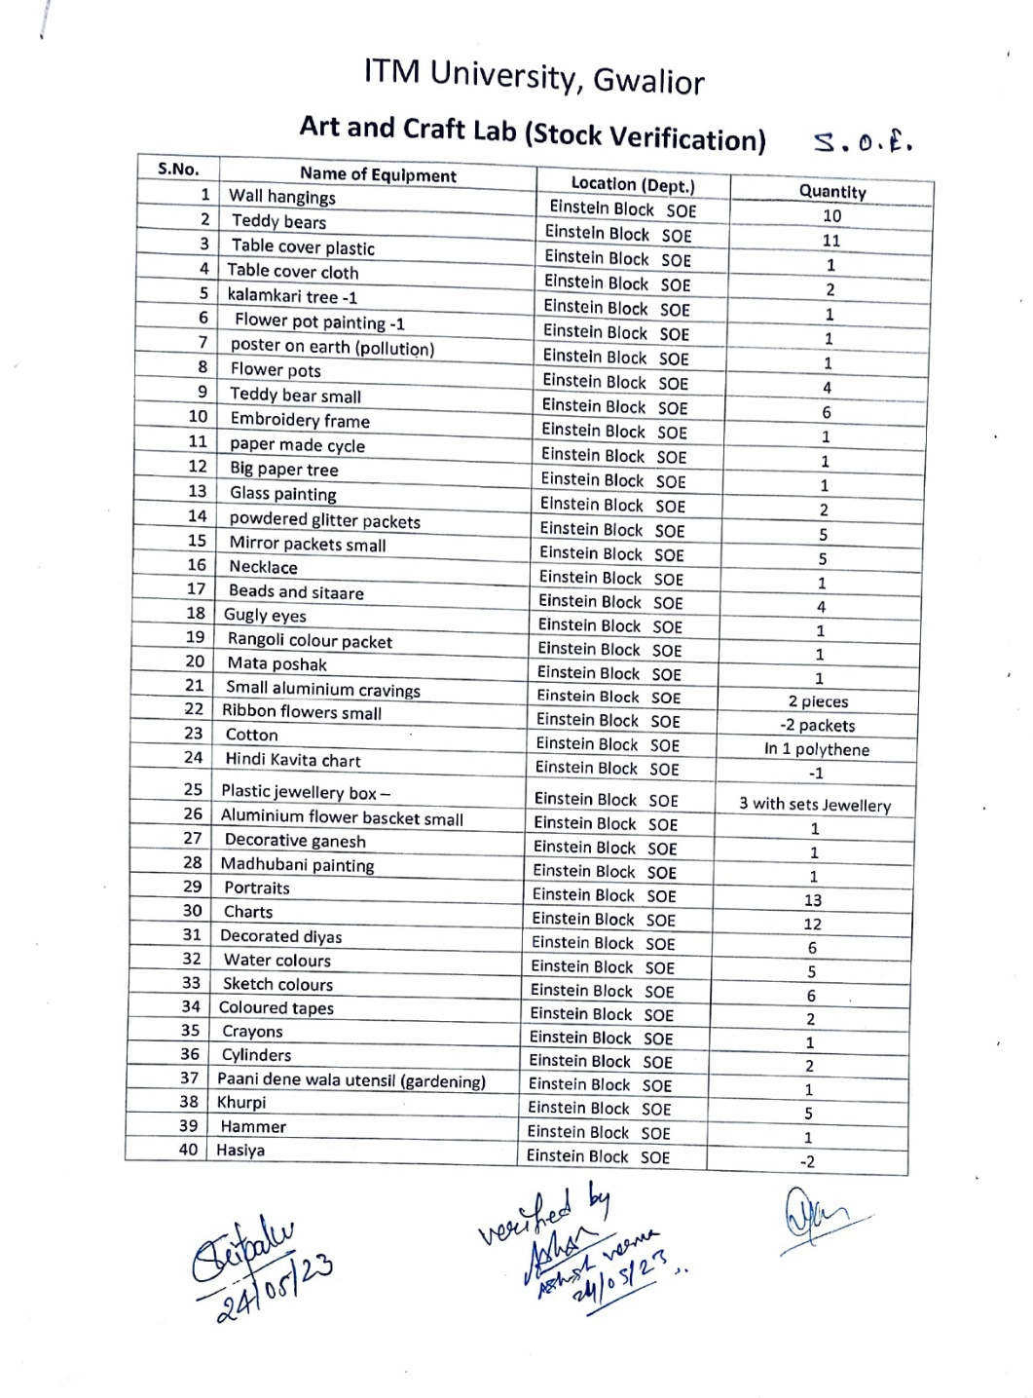

**ROOM NO. – EB –301 (Art & Craft Lab)**

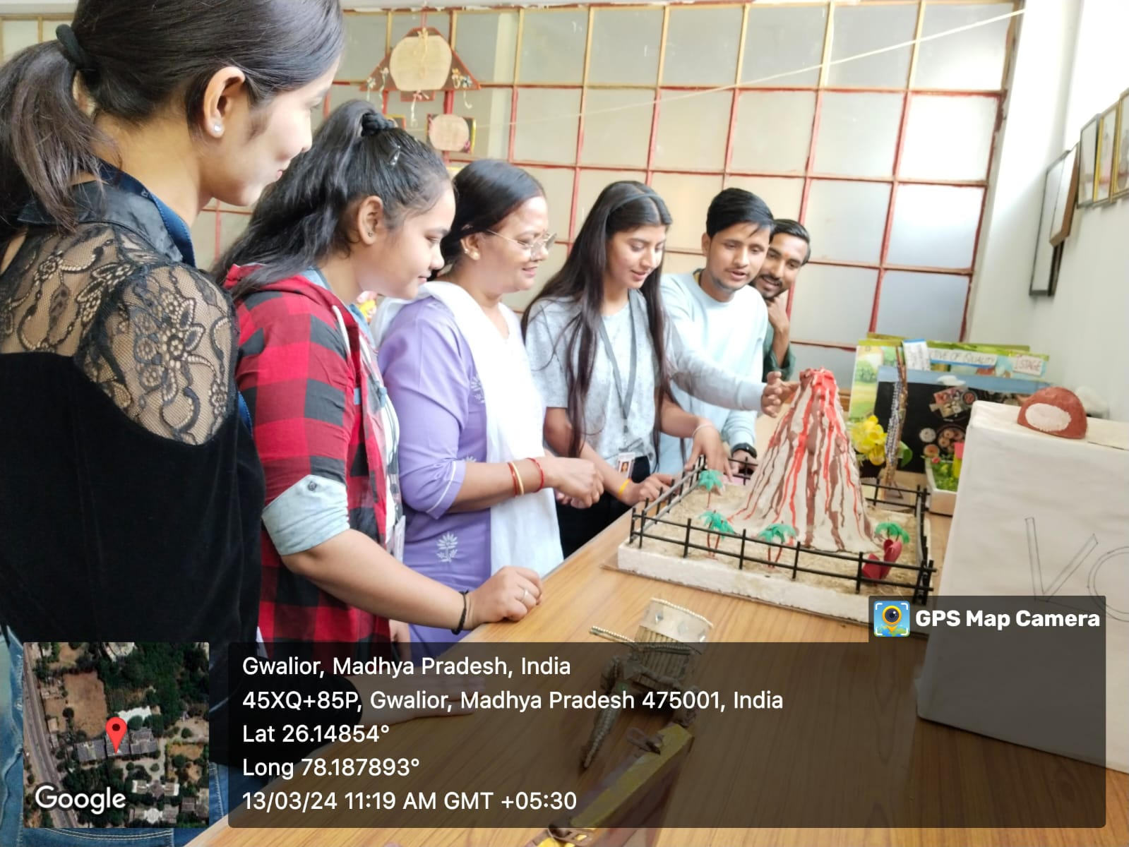

**ROOM NO. – EB –301 (Art & Craft Lab)** 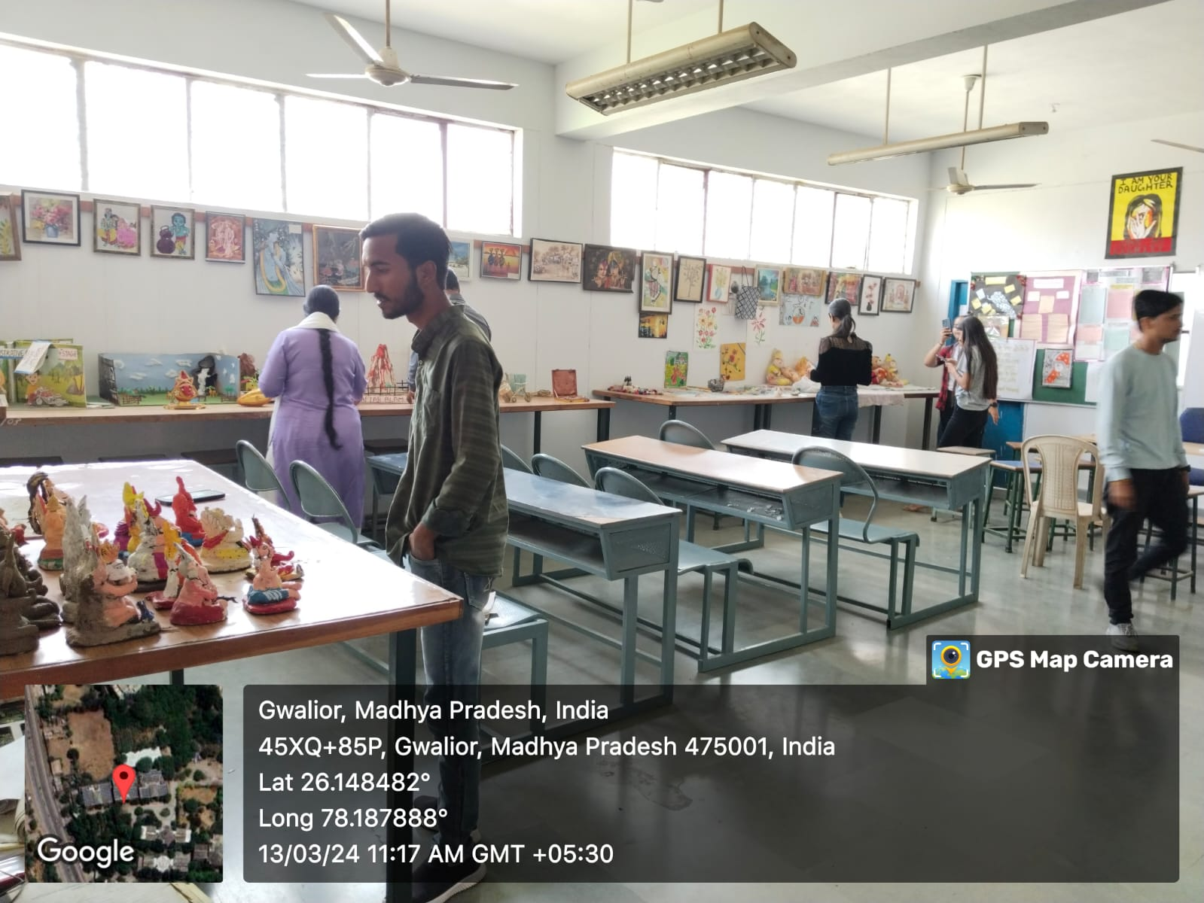

|  |  |
| --- | --- |
|  |  |
|  |  |



**SCHOOL OF EDUCATION**

**Description of Psychology Lab in Education:**

A Psychology Lab in education serves as a dedicated space where students can engage in hands-on learning experiences related to psychological theory, research, and practical applications. The primary objectives of a Psychology Lab include:

1. **Experiential Learning:** The lab provides opportunities for students to apply theoretical knowledge gained in classrooms to practical settings. They conduct experiments, observations, and simulations to understand psychological concepts firsthand.
2. **Research and Data Analysis:** Students learn research methodologies and techniques used in psychological studies. They design experiments, collect data, analyze results using statistical tools, and draw conclusions based on empirical evidence.
3. **Skill Development:** Engaging in lab activities helps students develop essential skills such as critical thinking, problem-solving, experimental design, data interpretation, and communication skills. These skills are valuable for both academic and professional pursuits in psychology.
4. **Understanding Human Behavior:** Through experiments and simulations, students explore various aspects of human behavior, cognition, perception, and emotions. They gain insights into psychological phenomena and theories, fostering a deeper understanding of human nature.
5. **Application to Education and Counseling:** Psychology labs often include simulations of counseling sessions or educational interventions. This allows students to practice counseling techniques, behavior modification strategies, and teaching methods in a controlled environment.

**Psychology Practicals –**

Intellegence Test- Short Term Memoory, Long Term Memory, Bhatiya Bettery Test, Mental Ability,

Attitude Test

Personality Test- TAT, Harman Rorcha Ink block Test, Picture test, Word association,

Interest Test

Achievment Test

Mirror Experiment

**LIST OF PSYCHOLOGY LAB EQUIPMENT**

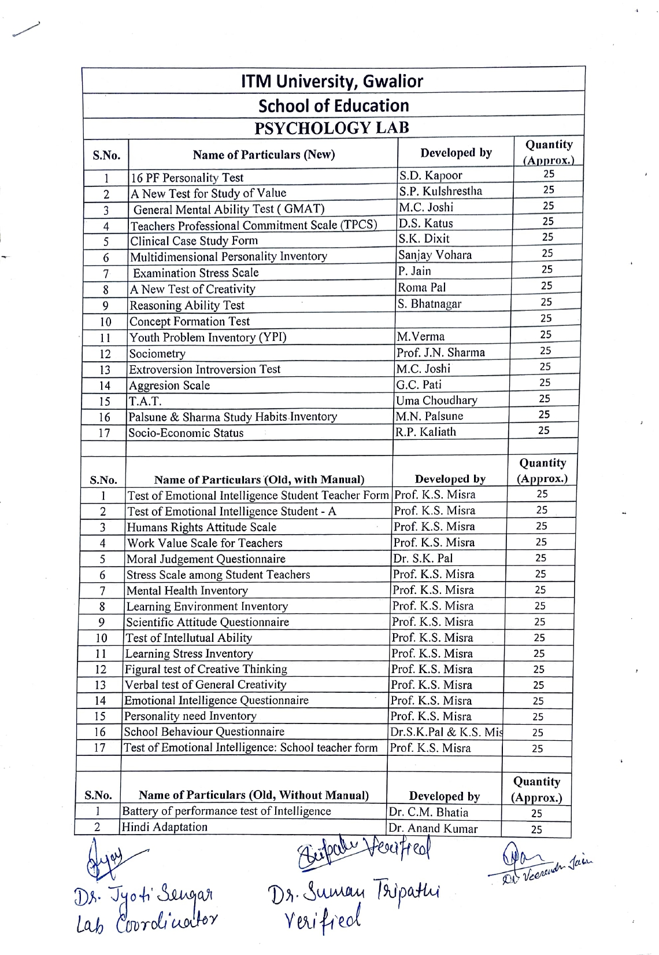

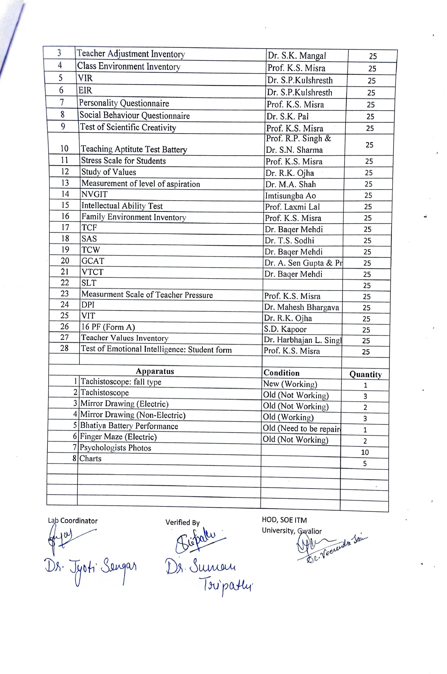

**ROOM NO. – EB –304 (Education Psychology Lab)**

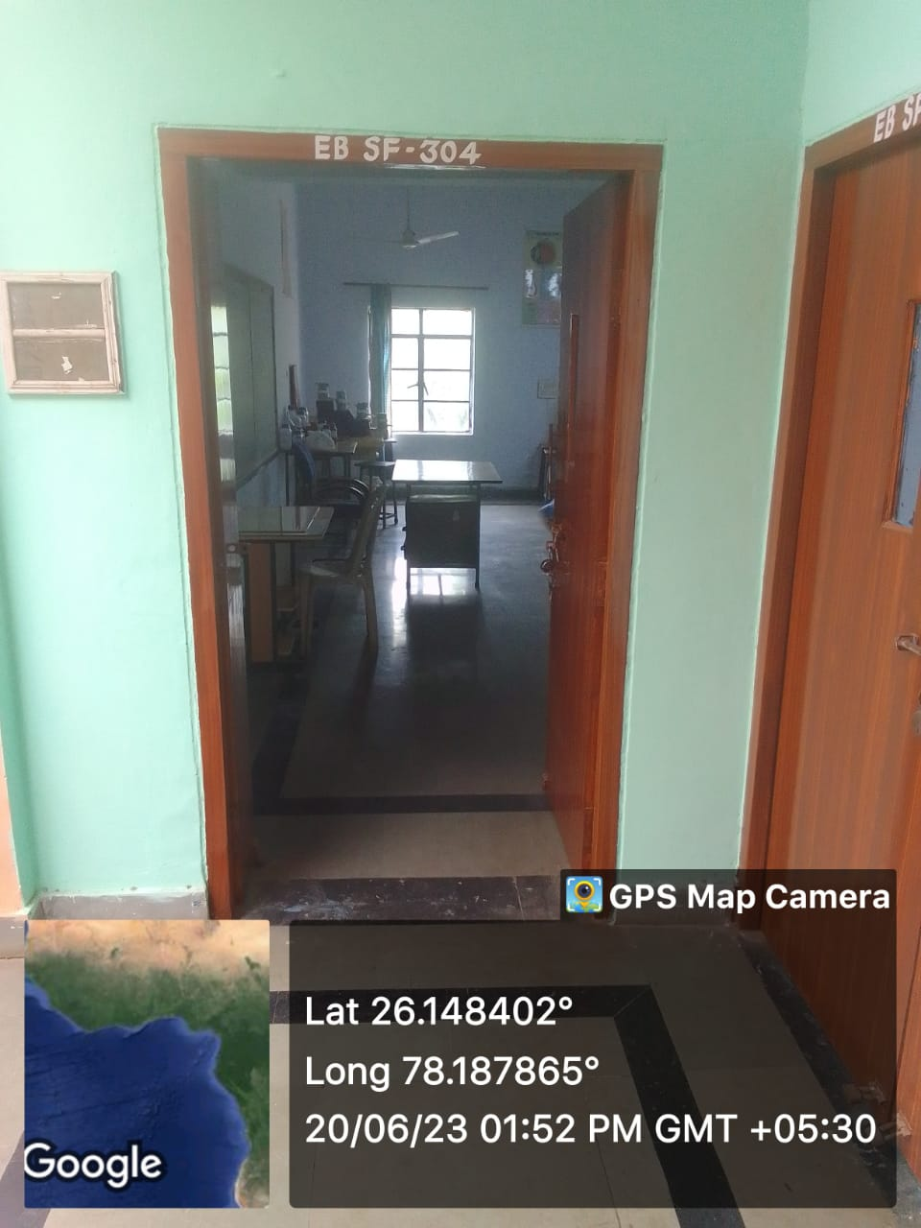



|  |  |
| --- | --- |
|  | |
|  |  |



**SCHOOL OF EDUCATION**

A Science Lab in education is a specialized facility equipped with scientific instruments, tools, and materials that facilitate hands-on learning and experimentation in various scientific disciplines. Here's an overview highlighting its purpose, components, and educational benefits:

**Description of Science Lab in Education:**

A Science Lab serves as a crucial component of science education, providing students with opportunities to engage in practical experiments, investigations, and demonstrations that complement theoretical knowledge gained in classrooms. The primary objectives of a Science Lab include:

1. **Hands-on Learning:** The lab provides a hands-on learning environment where students can explore scientific concepts through experimentation. They conduct practical activities, observe phenomena, collect data, and draw conclusions based on empirical evidence.
2. **Promoting Scientific Inquiry:** Students learn to formulate hypotheses, design experiments, and test predictions. They develop critical thinking skills as they analyze results, identify patterns, and make connections between theoretical concepts and real-world applications.
3. **Developing Practical Skills:** Engaging in lab activities helps students develop practical skills such as laboratory techniques, use of scientific instruments, measurement, data recording, and safety protocols. These skills are essential for careers in science, technology, engineering, and mathematics (STEM) fields.
4. **Fostering Curiosity and Creativity:** The lab environment encourages curiosity, exploration, and experimentation. Students are encouraged to ask questions, propose solutions, and innovate, fostering a spirit of inquiry and creativity.
5. **Integration of Technology:** Many modern Science Labs incorporate technology, such as computer simulations, data logging devices, and digital microscopes, to enhance learning experiences and simulate complex scientific processes.

**ROOM NO. – EB –304 (Science Lab)**

|  |
| --- |
|  |

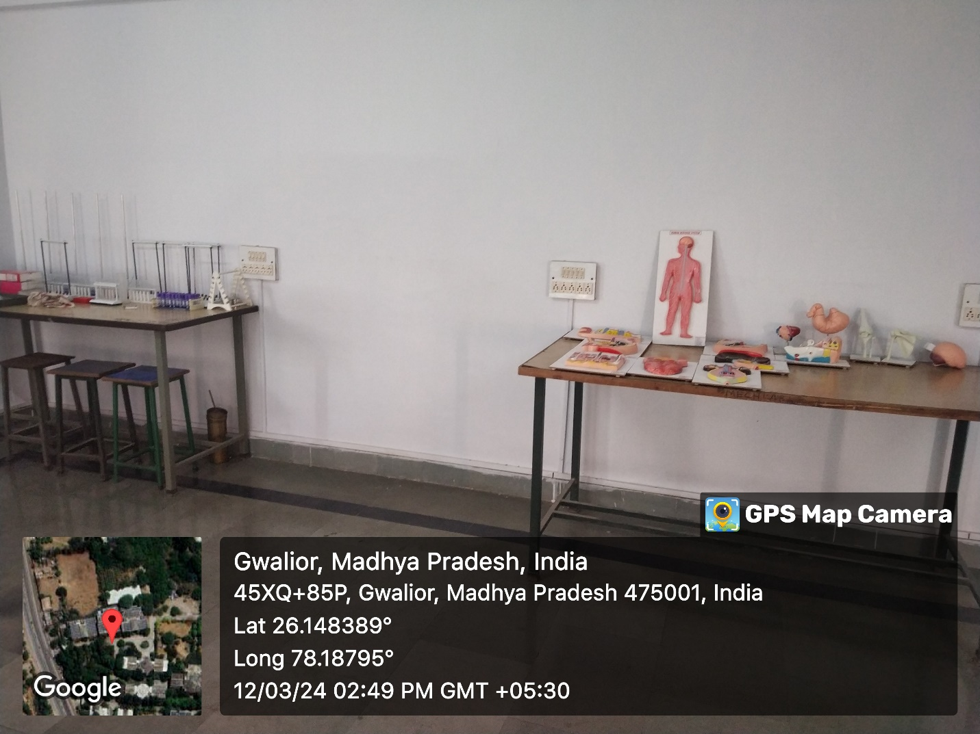

**LIST OF SCIENCE LAB EQUIPMENT**

